When you upload a file to SharePoint, it will normally be stored in the folder that you are currently viewing.  First logon to SharePoint, and then select Shared Documents. | 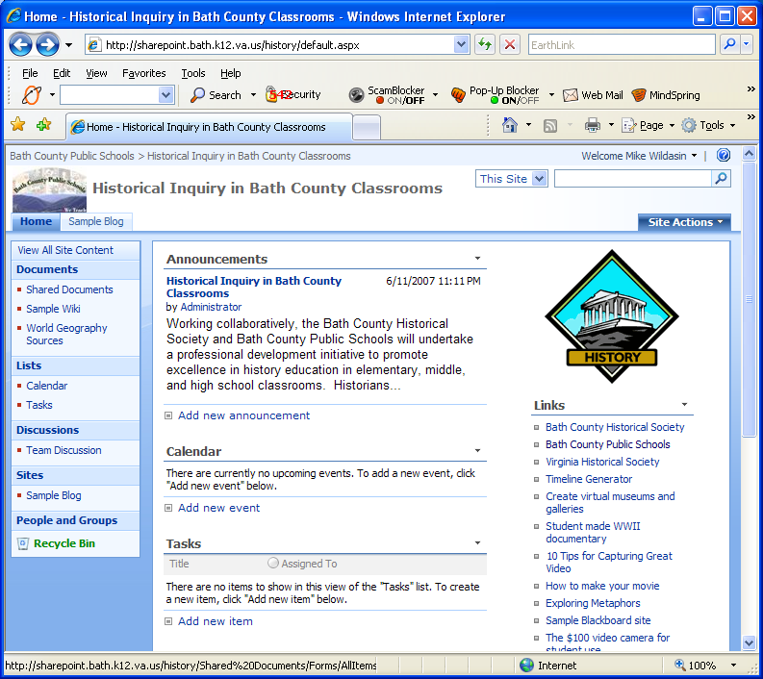
Assume that the file has been uploaded to the ‘common’ Shared Documents folder, but you would like to move it to folder Mike. | 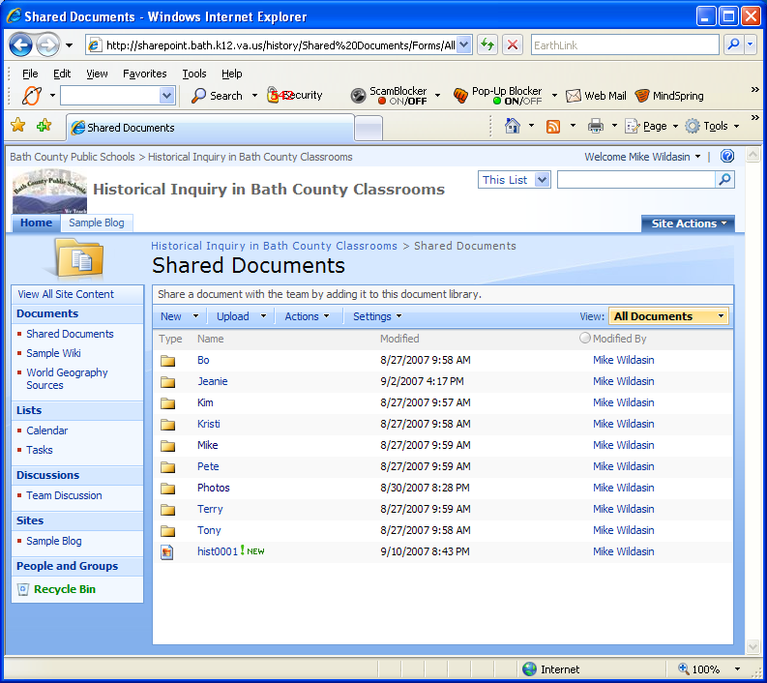
Place the cursor over the file name and click the down arrow . And select Send To ► Other Location | 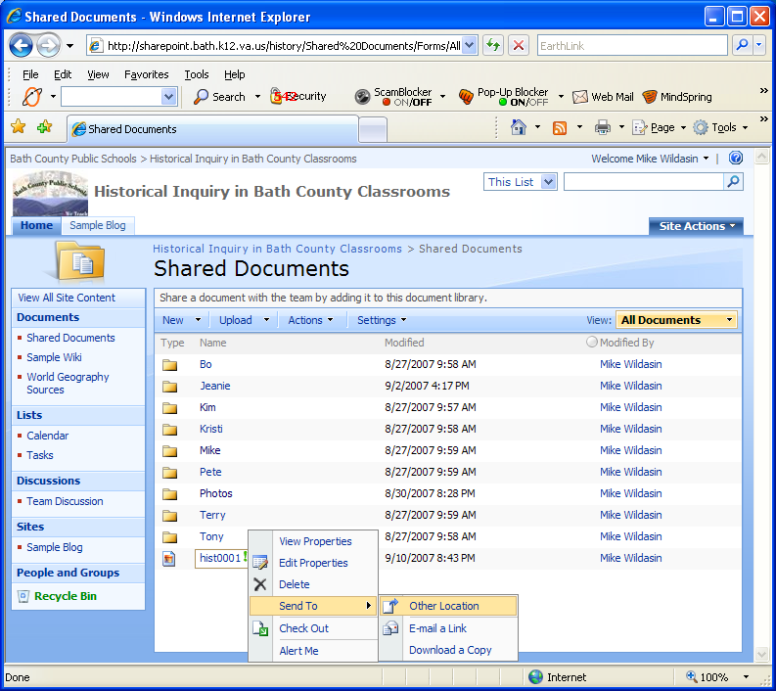
The Destination document library or folder will be the folder you are copying from. | 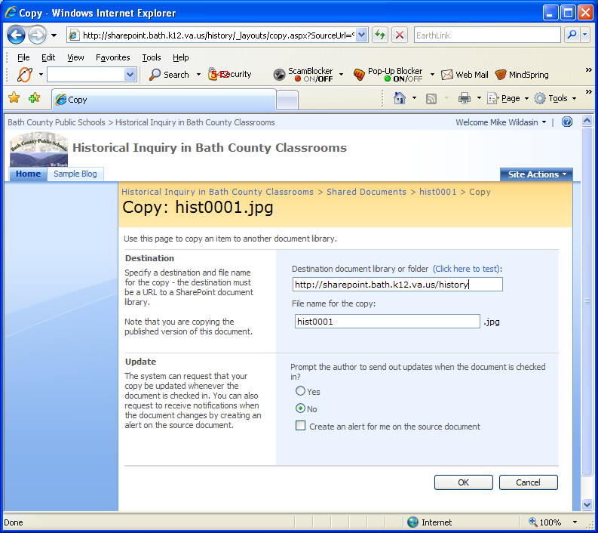
For this example we’ll move the file to Mike’s folder. Therefore we’ll add /shared documents/mike to the Destination document library or folder.  (Note: Don’t worry about upper and lower case, SharePoint will copy to the correct folder.)  If you want to change the filename of the copied file, you can do that in the File name for the copy: dialog box.  Click the button to start the copy process. | 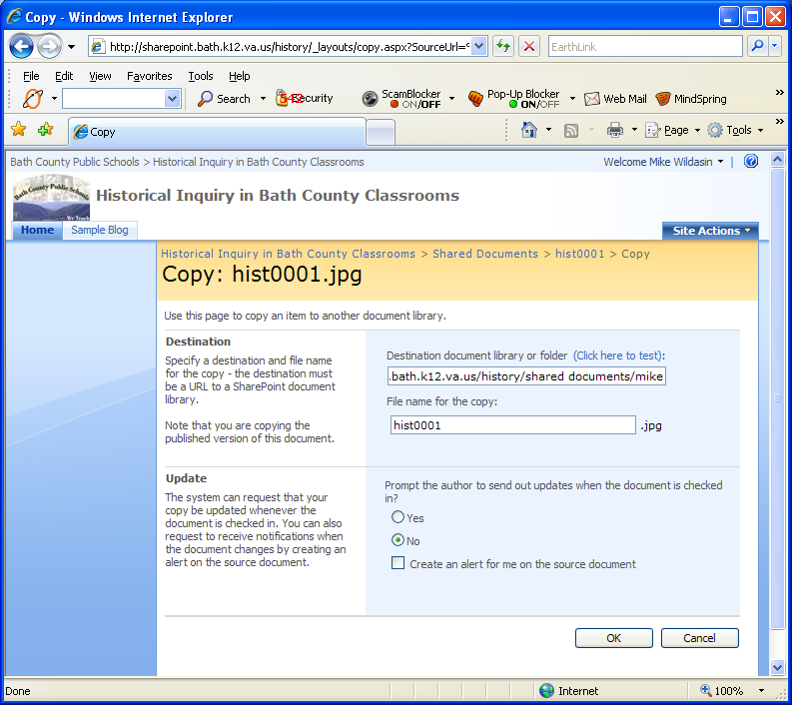
Click the button, to confirm that you want to copy the file. | 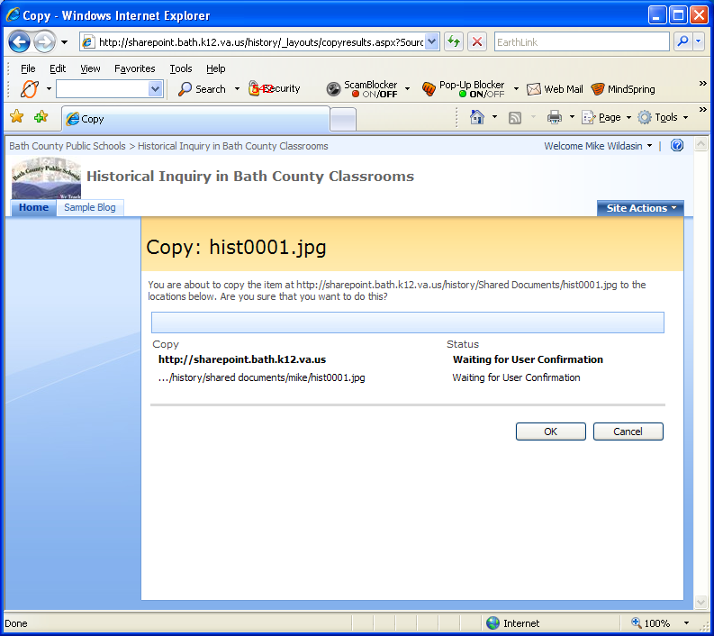
At this point it’s not really obvious how to get out of this screen.  One way is to click the back button three times.  Another way would be to click the tab, and navigate back to the Shared Documents folder. | 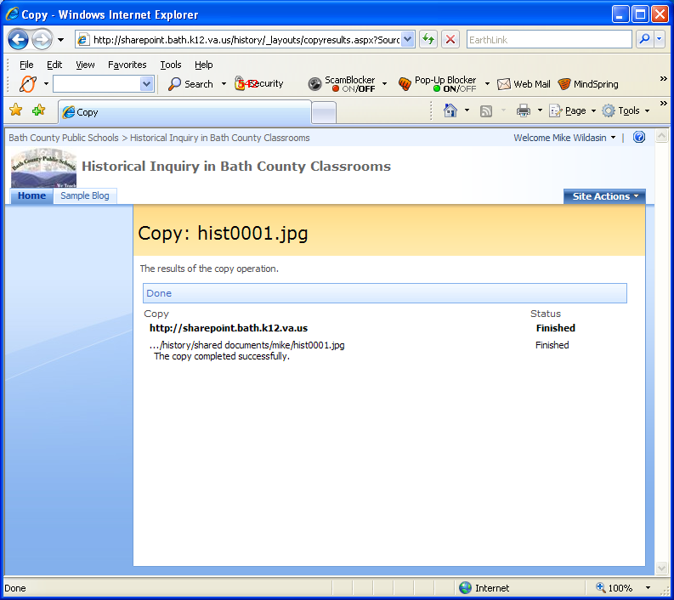
Here’s what happens if we click the back button three times.  We see that hist0001 is still in the Shared Documents folder. | 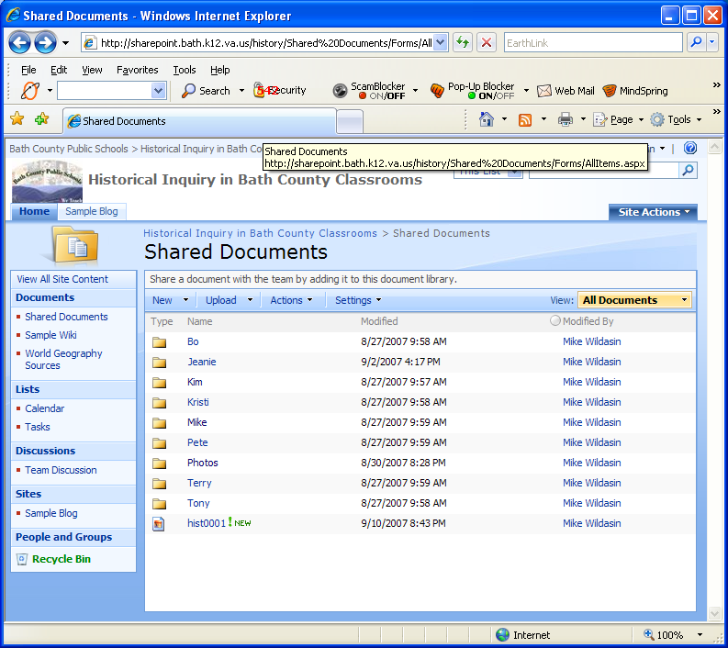
If we click on Mike we see that hist0001 is in Mike’s folder.  The file hist0001 now exists in two places. If we want to keep just the copy in Mike’s folder, click the back button . | 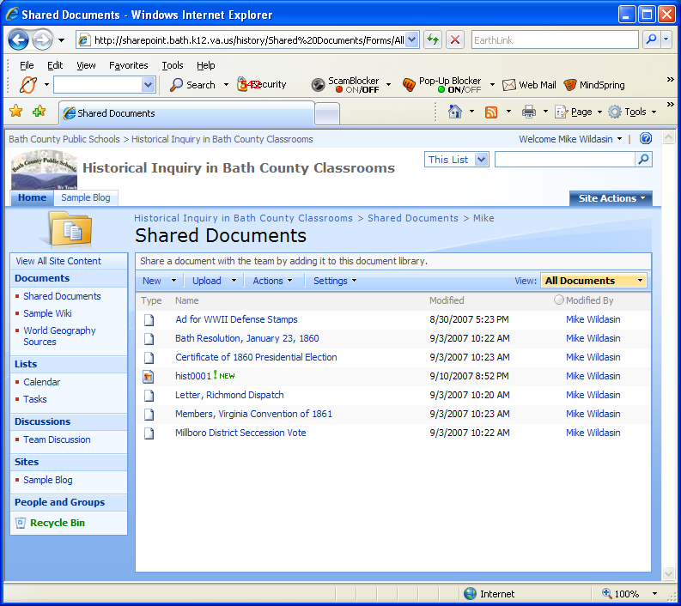
Place the cursor over the file name and click the down arrow . | 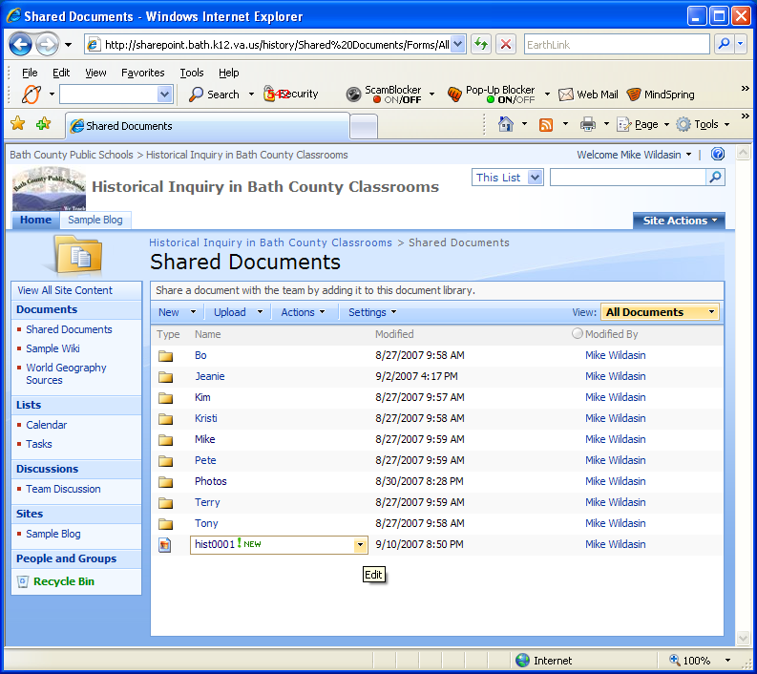
Select from the dropdown menu. | 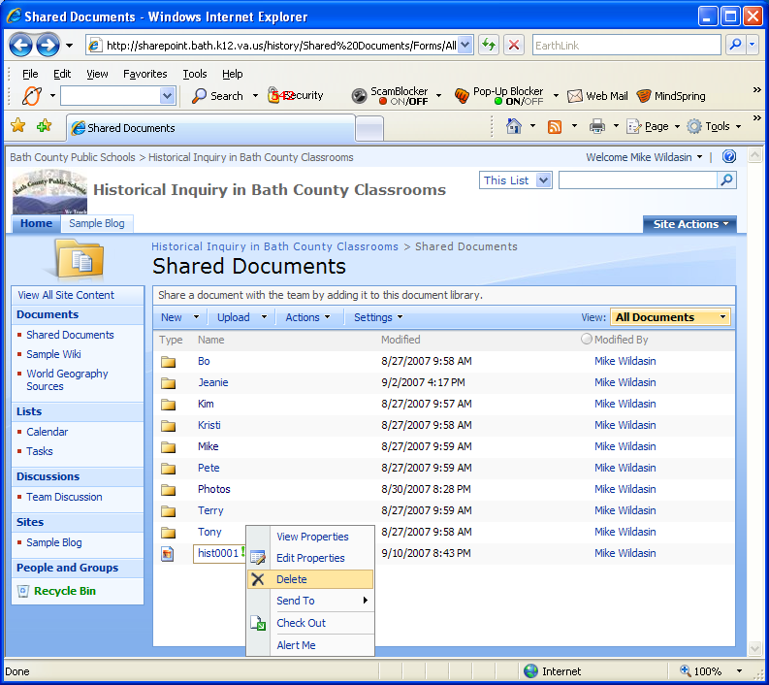
Click the button. | 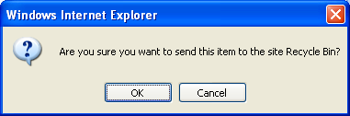
The file has been deleted from the general Shared Documents folder. | 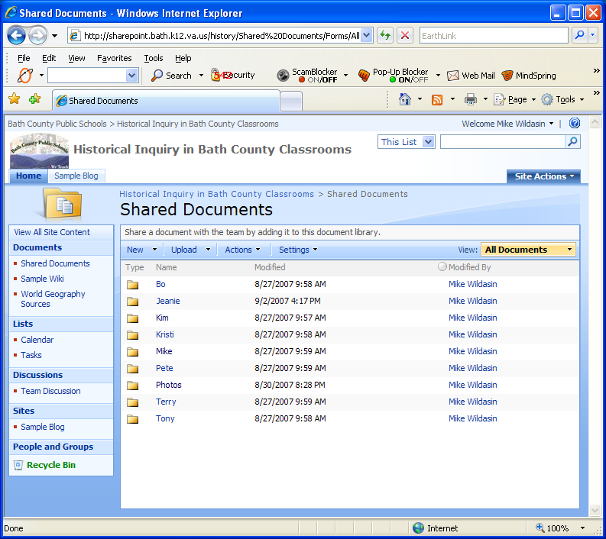
You can click on Mike to make sure that the file still exists in that folder. | 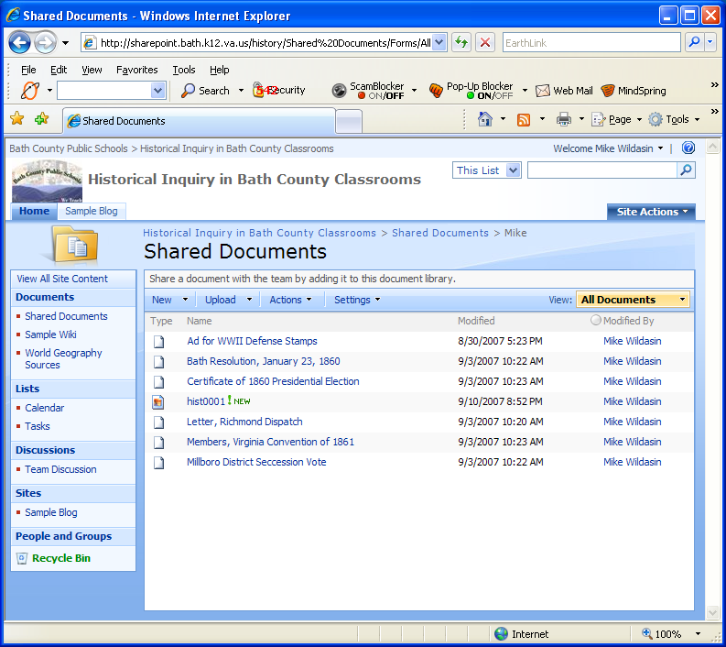
By clicking on hist0001 we can verify that the correct file has been copied. | 

